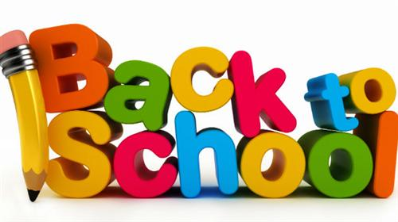

Brunswick Christian Academy
SA Class Personal Desk List
BCA School Wide: No spiral Notebooks of any kind
SA Room will create our own homework and communication book with calendar
1 King James Version Old & New Testament Bible
6 Packs of loose leaf 3 hole paper
6 Packs of index cards, any size & color
3 1” binders any color
NO SPIRAL NOTEBOOKS or multi-subject notebooks with metal spirals on the end
2 Composition book (any color)
1 Box of Kleenex
1 Container of Clorox or Lysol wipes

Part-Time SA Students:
For Bible, Math, and Language Classes in SA, You will need this for each class
1 1” Binder
2 Packs of loose leaf 3 hole paper
1 Pack of index cards, any size & color

For Science or Social Studies/History students you will need:
1 Composition book
1 Pack of index cards, any size & color

(Updated 5/2018)

