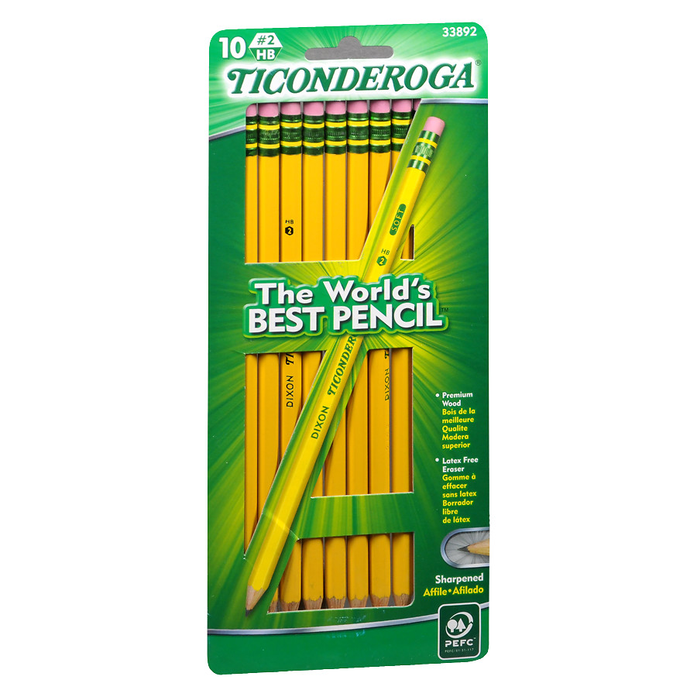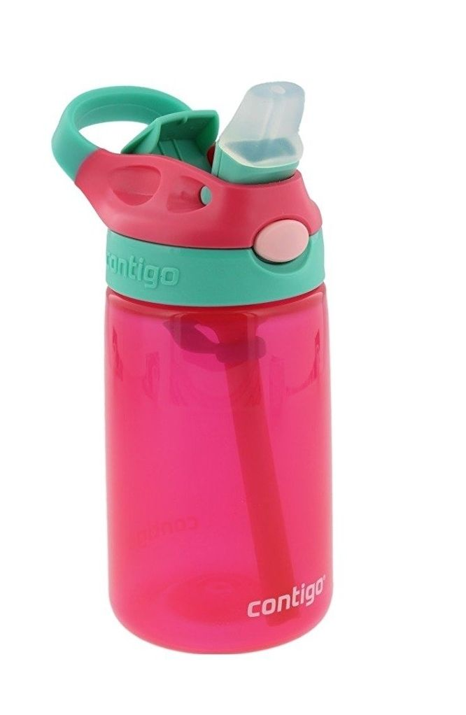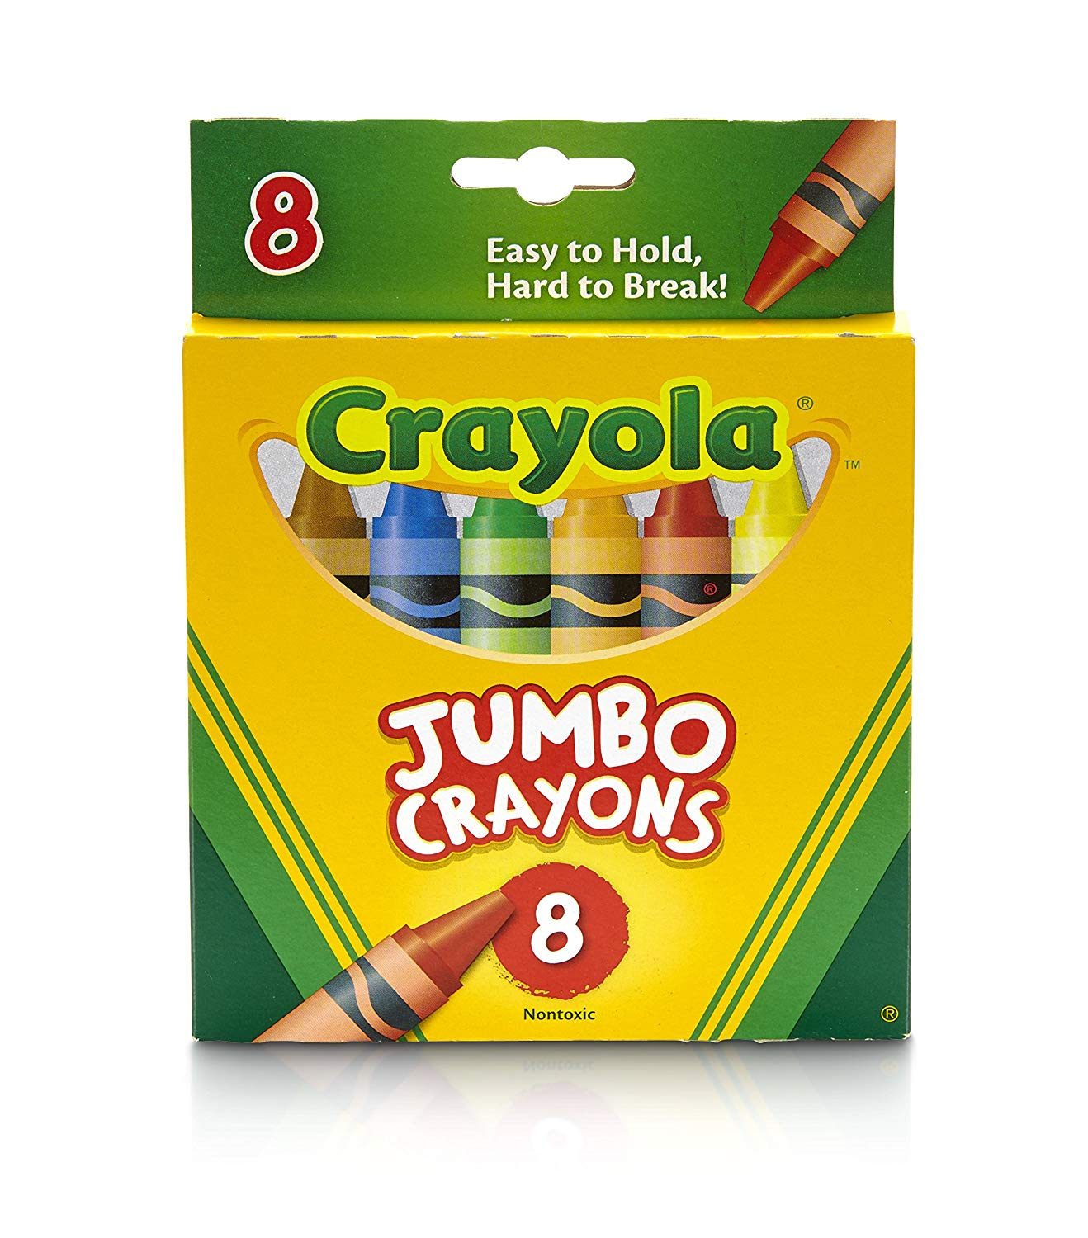

KINDERGARTEN SUPPLY LIST

- BACKPACK- NO CHARACTERS (please see Student Handbook)
- 1 PLASTIC FOLDER
- 2 BOXES JUMBO CRAYOLA CRAYONS
- 2 PACKS OF TICONDEROGA PENCILS (any color or size)
- 1 PACK OF THREE GLUE STICKS
- 1 COLORING BOOK (NO CHARACTERS)
- 2 BOXES OF TISSUES
- 2 HARD CONTAINERS OF BABY WIPES
- 2 BOTTLES OF HAND SANITIZER
- 1 CONTAINER OF CLOROX/LYSOL WIPES
- 2 BOXES OF GALLON SIZE ZIPLOCK BRAND BAGGIES
- 1 BOX OF QUART SIZE ZIPLOCK BRAND BAGGIES
- 1 NO-SPILL WATER BOTTLE (TO BE BROUGHT TO SCHOOL EVERYDAY)
- 1 RAIN COAT WITH A HOOD AND ZIPPER Will be kept at school
- 1 COMPLETE UNIFORM (INCLUDING UNDERWEAR AND SOCKS)
Will be kept at school

(UPDATED 07/1/2019)

