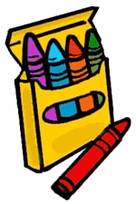
Brunswick Christian Academy
K5 Personal Desk List

1 Plastic folder
2 Boxes (8 count each) Jumbo Crayola Crayons
(No glitter crayons or fluorescent colors)
4 Primary pencils- No erasers (can be purchased in the office)
2 Packs of 3 glue sticks (Elmer’s only)
2 Boxes of tissues (rectangle boxes)
2 rectangle boxes of BABY wipes (no canisters please)
1 Bottle of Hand Sanitizer
2 Containers of Clorox or Lysol Wipes
2 Boxes of Gallon size Ziplock brand baggies
1 complete change of clothing (to be kept at school)
1 Plastic rain poncho or rain coat (please no umbrellas for safety reasons- they will be kept at school)
NO PENCIL OR CRAYON SHARPENERS

(Updated 05/2018)

