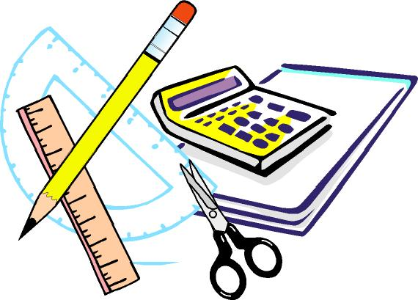
Brunswick Christian Academy
9th, 10th, 11th, & 12th Grade Personal Desk List
1 King James Version – Old & New Testament Bible
Highlighters (different colors) – All classes
Scientific Calculator (Math)
#2 Pencils for math (Can be mechanical)
Wide Ruled notebook paper (NO SPIRAL NOTEBOOKS)
2 Composition books – Science Fair
3 Report Folders - English
1 Binder (1” wide) (Math)
1 Binder (1” wide) (English)
1 Package of notebook dividers (English)
1 Pack of graph paper (Math)
Ruler (Math)
Protractor (Math)
Compass (Math)
1 Steno pad for homework / or a day tracker
2 Pack of 3 x 5 note cards
High School Art Class
- Large old t-shirt to be used as a smock
- Sketch Pad (for homework)
- 12 x 12 Scrapbook with at least 10 pages
2 Boxes of tissues
1 Package of dry erase markers (LOW ODOR)
Large pink erasers (Math)
Red grading pencils (Math)

Revised 5/2018

