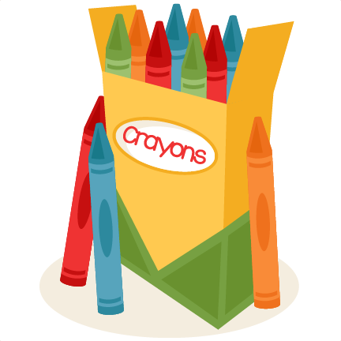

Brunswick Christian Academy
1st Grade Personal Desk List

1 Solid color book bag
2 Boxes of 24 Crayola Crayons (No glitter or fluorescent colors, I prefer Crayola brand) * Watch for sale prices
1 Pack of #2 pencils ( I prefer the brand, “America’s pencil, U.S.A. Gold)
12” Ruler with metrics
1 Pair of blunt scissors
1 Steno Pad for homework (6x9) (No composition notebooks)
3 Folders with pockets only (plastic type last longer)
3 Glue sticks
1 Small bottle of liquid glue
1 Child sized umbrella
1 Pencil bag (Heavy duty vinyl is best or canvas) No net bags.
NO PENCIL SHARPENERS
NO BOXES OR STORAGE CONTAINERS

(Please write your child’s name on all items with a permanent marker. Scissors, Pencils, and glue should be taken from the packages, and names clearly written on them.)

(Updated 5/2018)

